Meta Description:
This beginner’s guide to PPC helps you understand the fundamentals such as types, platforms, working and much more. Read and be a PPC in no time.

The Beginner's Guide to PPC in 2025
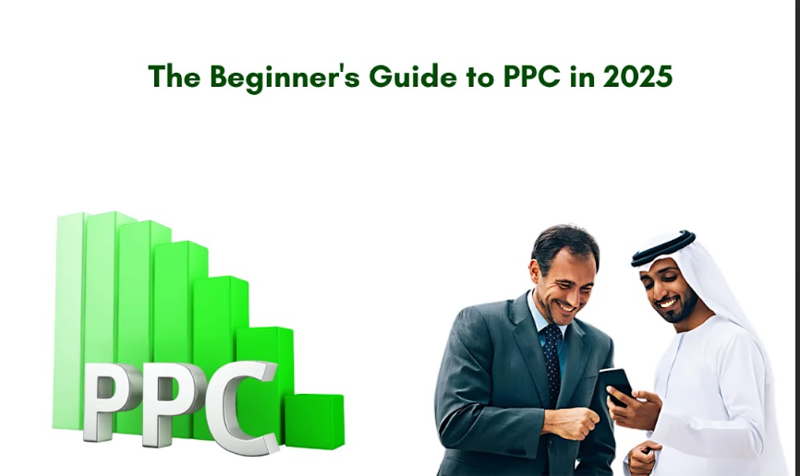In the year 2025, Pay-Per-Click (PPC) advertising is expected to occupy a commanding position in the field of successful business marketing. No matter if you are a novice or a professional businessman, your knowledge of PPC helps you to get higher traffic, get leads, and eventually turn leads into customers. In this beginner’s guide, you will find out what PPC is, its types, and how it works within the sphere of digital marketing.

I. What is PPC (Pay-Per-Click)?
It is a technique of web advertisement where an advertiser pays a commission amount when a consumer clicks on the ad link. Basically, it is an approach of paying for the visits to your site instead of trying to get those visits organically. In the case of PPC, brands pay to get to the top of search results on a particular keyword of the targeted demographic.

Importance of PPC for Businesses
If a business wants to drive the desired traffic and concentrate on conversions, it is essential then not to underestimate the importance of PPC Services in Dubai or any other part of the world. With the help of PPC, you can make services and product exposure easier because it allows the company to share information with its potential customers.

Historical Context and Evolution:
Indeed, PPC advertising has been in existence for many years. It began with the first year of online ad networks in the lattermost years of the decade of the nineties. The buying behavior of consumers, over the years, has for instance undergone a lot of changes due to developments in technology and changes in traits. By 2025, PPC will continue to evolve with the best features where AI or machine learning plays a major role in determining the PPC ads and their targeting.

II. Types of PPC Ads:
Let's talk about the different types of PPC Ads you can come across in the digital world:
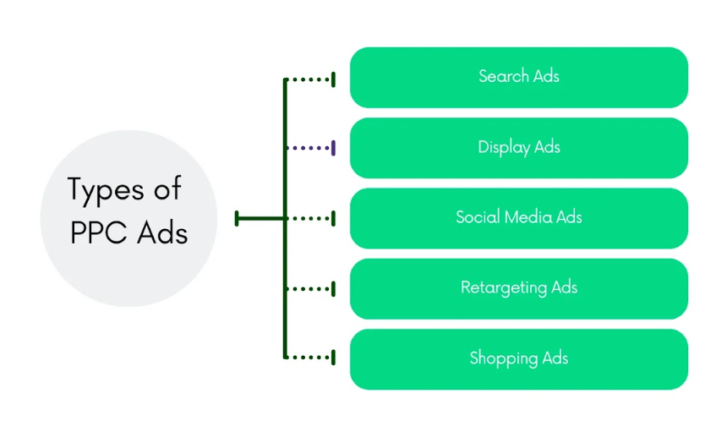

Search Ads:
Search ads are displayed on the SERPs, about a particular search query made by a user. Such ads are quite selective as they appear only in the result pages when users have searched for certain keywords.

Uses & Benefits:
Unlike the other types of ad products, search ads are perfect when you seek to target users with high purchase intentions. Search ads possess high targeting capabilities and should be used when a brand wants to share information about new offers or launch new products in the market.

Display Ads:
Display ads are graphical ads placed on publisher-owned websites. It can include news, blogs, images, and videos on platforms like YouTube, Facebook, Twitter, and other such social networking sites.

Suits For:
Display advertising is more suitable for creating brand visibility as well as the retargeting of an ad. They are versatile during the workflow and are useful to reach out to a large number of people.

Social Media Ads:
Social media ads are placed on platforms such as Facebook, Instagram, linked, etc. They take advantage of target groups’ availability by using platforms that contain a broad number of users.

Specificities and applications:
The most outstanding feature of social media ads is that they are useful for engaging the audience in a more engaging way. Stories can be made in different formats and can be adapted to the goals and objectives of an advertiser whether it is carousel ads or any other type of Ads.

Retargeting Ads:
Retargeting ads are an online display ad form of marketing that targets people who have visited a specific website or used a particular application.

Special Characteristics and Application:
Retargeting is, in fact, one of the most effective solutions for recalling those customers, who did not complete the purchase and left the site. It requires and promotes the brand while reminding the users to complete their purchasing process.

Shopping Ads:
Shopping ads display individual products within the ads with information such as the picture, price as well as the rating of the merchants.

Benefits, Features, Usage:
Shopping ads are ideal for any firm dealing in or selling products on the Internet. Such ads provide an immediate way of shopping, which helps to convey high-quality traffic right to product details pages.

III. The Difference Between PPC, SEM, and SEO

What is Search Engine Marketing (SEM)?
SEM refers to all the marketing activities that are targeted at improving the website’s ranking on SERPs. It involves paid advertisements also known as pay-per-click (PPC) alongside other common methods such as search engine optimization (SEO).

What is Search Engine Optimization?
SEO refers to the process through which the website is optimized to be ranked higher in the listing provided by the search engine. The main strategies of SEO are to enhance the site structure, the quality of content and the backlinks.

Key Differences:

PPC and SEM:
PPC is one of the most effective methodologies of SEM. Whereas PPC literally denotes that the company will pay for the number of clicks received on ads, SEM is a general term that encompasses paid as well as non-paid techniques for enhancing website visibility.

PPC vs. SEO:
PPC’s advantage lies in the principle that ads are instantly placed on the top of the results page as soon as the campaign has been set up. On the contrary, SEO can be a short-term activity aimed at occupying the top service rank through organic means during a specific period.

How PPC Complement SEO?
It is also worth mentioning that PPC and SEO strategies can be used simultaneously as both approaches complement each other. PPC enables gaining rapid results and understanding of the functioning of key phrases and the title of the ads. On the other hand, SEO helps an organization achieve high organic search engine results.

IV. Top PPC Platforms
Over the years, several types of PPC have been developed, and they all have their advantages and limitations when used in the PPC process. Here are some of the major PPC platforms that you need to be aware of in 2025:
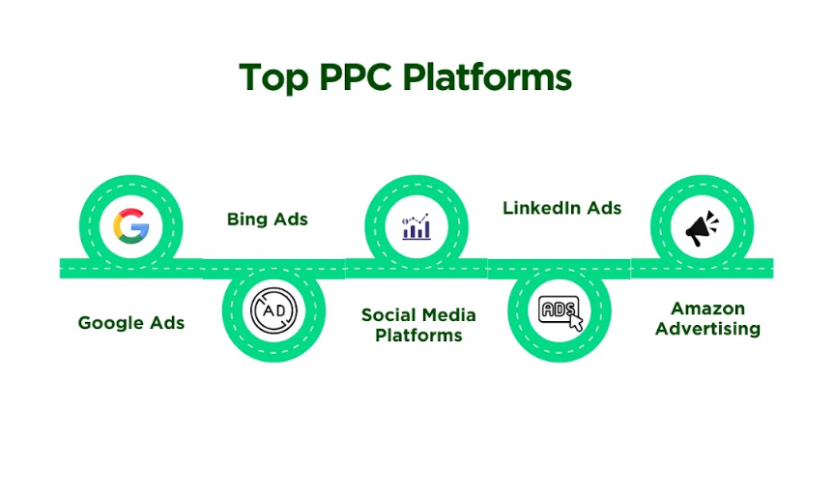

Google Ads:
Of all forms of PPC advertising, Google Ads is still unarguably the most dominant player at the moment. Google Ads have an extensive user base and directly targeted advertising capabilities making it a favorite among advertisers.

Strengths:
- Largest search engine with the highest volume of search traffic.
- The other benefits of the platform include target selection which includes keywords, location, and devices.
- Full-fledged analytics and reporting in HTML, Excel, PDF, and other formats.

Weaknesses:
- Due to heavy competition the factor of cost is also on the rise with every passing day.
- Some observers pointed out that Google Ads has a complicated user interface that can be confusing to the user especially if he/she is not tech savvy.

Bing Ads:
As a member of the Microsoft Corporation, Bing Ads is a serious and often effective competitor to Google Ads targeting different audiences.

Strengths:
- Less competitively priced than Google Ads, it might be even less expensive.
- This feature makes it even easier and convenient for users who often utilize Microsoft products and services.
- Specific target audience active in technological innovation and computer games.

Weaknesses:
- Disparity in the traffic search as compared to that searched in Google.
- This type of advertising comes with several disadvantages, one of which is the lesser exposure compared to Google Ads.

Social Media Platforms:
Social networks are now important actors in the sphere of paid search as they provide valuable targeting options that are based on user’s behavior.

Facebook & Instagram Ads:

Strengths:
- Massive user base with diverse demographics.
- Interests, behaviors, and demographic targeting have always been considered as some of the most effective targeting options today.
- The social aspects of utilizing rich formats of media for engaging advertisements.

Weaknesses:
- Changes in algorithms have impacts on ads that are placed on the site.
- Views on privacy and further limitations in the provision of data may influence targeting.

LinkedIn Ads:

Strengths:
- Ideal for B2B advertising and professional audiences.
- This is one of the most specific targeting possibilities in comparison with other social networks depending on the job titles and industries or company size.
- Business-related content enjoys high engagement rates.

Weaknesses:
- Generally, it requires a relatively longer time to accumulate a huge number of fans as compared to other social networking sites and it is also more costly per click as compared to the others.
- Restricted to professional business contacts only that might not help all types of business firms.

Amazon Advertising:
Amazon's Advertising provides unique advertising opportunities that allow any e-commerce business to reach the intending consumer at the point of purchase.

Strengths:
- Direct access to a large audience of shoppers.
- Effective for product-specific targeting.
- Integration with Amazon’s vast product catalog.

Weaknesses:
- High competition in popular product categories.
- Bid formation, bid evaluation, top management involvement, and complexity of bidding decisions.

Other Emerging Platforms (e.g., TikTok Ads, Pinterest Ads)
It is important to take note that as digital platforms continue to emerge with newer forms, there are also new PPC opportunities that are available to clients.

TikTok Ads

Strengths:
- Growing user base, particularly among younger audiences.
- Participants pointed to a creative ad format that attracts people's attention and lets them engage with the advertisement.
- Viral potential through user-generated content.

Weaknesses:
- This platform is relatively young in almost every aspect, especially concerning targeting and data analysis.
- Rapid changes in platform trends and algorithms.

Pinterest Ads

Strengths:
- For lifestyle and fashion brands, this platform offers a great strong visual discovery.
- The option of long-tail keyword targeting is also available which enables you to pinpoint a given market in detail.
- Users typically demonstrate high intent or purchasing.

Weaknesses:
- Can be applied only to items that contain some form of image or can be linked, which may not be applicable to all products.
- There are some drawbacks when using this social media platform as compared to more popular ones.

V. Why PPC is Important?
Internet advertising in general and PPC advertising in particular is no longer just a trend; it is a key business advantage plan for any business that wants to succeed in the contemporary world. Here’s why PPC is important:

Immediate Visibility and Traffic
PPC offers immediate recognition for the brand since it entails placing your brand on websites that people trust. It is, however, important to note that while organic SEO and PPC AdWords may take weeks or months to show results the PPC ads are immediately published with traffic following shortly.

Precise Targeting Capabilities
One of the best things that PPC has is the ability to target your ads rather selectively. Whether by geographical, age, interest or keywords, you are able to target a specific group of audience so that the Ad is likely to be clicked on by the target customers.

Measurable Results and ROI
PPC offers one of the biggest benefits of record measurability as it enables Website owners to know the ultimate results of their endeavors. Thus, you can monitor all clicks, conversions, and spending to evaluate your campaigns’ efficiency and make relevant effective decisions on improving it.

Flexibility and Control Over Advertising Spend
PPC provides the most flexibility in the control of advertising costs among all the online marketing strategies. With mobile ad campaigns, you are able to control daily or monthly spending by either increasing or decreasing the bids whenever you want to or having the option of simply stopping a campaign you are running.

VI. How Does PPC Advertising Work?
How exactly PPC advertising works is very important when you want to design campaigns. The following is the site

Key Components: Ad Auctions, Bids, Quality Score, and Ad Rank

Ad Auctions:
Each time the user searches or engages themselves in any activity involving the platform, ad auctions take place. It works through keyword referring, the advertisers place their bids and the ads with the best bids will be aired.

Ad Costs:
Cost per click or bid is the highest amount you are willing to pay in order to have one click on the ad placed. However, the actual cost fo an ad can be lower depending on a number of conditions like Quality Score.

Quality Score:
It is another feature of PPC Ads that measures the quality of keywords, ads, as well as, landing pages. A higher Quality Score means that the cost decreases and the position of the advertisement also increases.

Ad Rank:
Looking at ad position, the selection is known as Ad Rank, which determines the position of your ad in an auction. It depends on your bid, Quality Score and also other attributes such as ad extensions.

How Advertisers Set Budgets and Goals?
Budgeting and goal setting refer to one of the initial processes of carrying out a PPC campaign. Here is a plan of action on how to approach it:
- Budgeting: Discuss with your company the daily/ monthly budget that will suit the marketing plan of the Company. All the monitored platforms provide the ability to modify the budget at any given moment.
- Goal Setting: Set measurable objectives for your PPC campaign to achieve goals of high traffic, leads or sales. It will aim at helping your targeting, bidding, and performance measurements for your goals.
Overall, PPC advertising in 2025 enables organizations to create an effective advertising campaign to capture consumers. Leverage yourself with PPC, and your business must prosper with the evolution of the business world into the digital sector.

VII. How PPC Works in Google Ads
Google Ads still holds the title of the best PPC platform because of the exposure it has to provide to advertisers. Through the use of this platform, advertisers can target their potential customers by posting ads on Google-affiliated websites such as YouTube and the Google Display Network.

Setting Up a Google Ads Account:
It is very easy to set up a Google Ads account and even easier to follow the steps that Google provides to implement it.
- To begin with, you should open the www.google.com website, then click on the link “Ads” and further on “Start Now.”
- To do this, you will have to log in using the Google account you possess or create a new one.
- When creating the support, you need to answer numerous questions about your company’s name, geographical location, and type of business.
- You also need to choose a payment method as Google demands it before you test out your campaigns.

Understanding of Keywords, Ad Groups, and Campaigns

Keywords:
Keywords are usually the keys to PPC advertising and marketing. It is the words that a user inputs to search engines to look for related information. In Google Ads, you will have to choose the appropriate identifiers that relate to your products or services.

Ad Groups:
An ad group is a set of words and advertisements with related characteristics. Ideally, each ad group advertises one product or service to be marketed, which makes the process less general.

Campaigns:
Campaigns are grouped advertisements and can be defined as the top level of the AdWords hierarchy. It is a big container in which you arrange your ads and also define the total sum of money you are willing to spend and general options for choosing the target audience.

How Google’s Auction System Functions?
Google Ads works based on the bidding system through which the advertisers bid for keywords.
When a user types in a keyword Google searches through its advertising exchange to come up with suitable ads to exhibit.
The auction process involves a few metrics such as the bid price, ad relevance and relevance of the user to your ad.
The top position is only allotted to the highest bid. However, the last position and CPC depend on the bid of the auction.

VIII. PPC Keyword Research
Keyword study is one of the most important factors when it comes to PPC because it plays a significant role in PPC.
Keyword research make sure your ads will be visible to truly interested audiences that are actively seeking services similar to the one you offer.
This tells you the importance of selecting the proper keywords so it helps you make the most of your ad money, as well as the possibility of the ad conversion.

Tools and Techniques for Effective PPC Keyword Research:
There are some tools that can be useful while practicing keyword research:
- Google Keyword Planner: An important tool that is linked with Google Ads, offers keywords and their performance insights.
- SEMrush: The tool provides extensive keyword analytics, with a particular focus on an analysis of competitors.
- Ahrefs: Known for the great amount and keyword difficulty estimated.

How to Identify and Choose High-Performing Keywords?
First of all, it is worth compiling a list of keywords, which are connected with your business.
Refer to keyword research tools to broaden this list and collect results. Find more related keywords and gather information on traffic rates, competition, and tendencies. Also, look for terms that have a good number of monthly searches but relatively low competition.
It is also important that long-tail keywords are even more effective because they are narrower and less competitive than the basic keywords.

IX. PPC Campaign Management:
The management of PPC depends on constant monitoring and regular amendments. Ensure that you devote a certain portion of your week to going through data regarding your campaigns’ effectiveness and adjusting it accordingly. Here are some ongoing management techniques to run successful PPC campaigns:

Monitoring Performance Metrics:
The following are some measures you need to employ to monitor performance metrics effectively:

- Click-Through Rate (CTR): The chances of an individual actually clicking on an advertisement upon getting a glance at it.
- Conversion: It is the ratio of users who take the required action to the number of people who visited the particular website or webpage.
- Cost per Acquisition: This measures the amount of money that is spent in acquiring the conversion rate and helps you determine the effectiveness of your conversion campaign.

A/B Testing Ads and Landing Pages:
A/B testing is a technique that compares the effectiveness of two advertisements or the landing pages that are used by a particular company. Experiment with headlines, the ad text, images and buttons to determine what works best.

Adjusting Bids and Budgets:
You should also track your bid levels and the amount you assigned for each bid. As a result, it would be wise to raise bids for the keywords that perform better, or lower and pause those that do not. Specific strategies include adjusting expenditures for particular campaigns based on performance against the set goals and spending according to the company’s overall target.

Utilizing Automation Tools and Features:
A few of the measures of automation from Google Ads include tasks like adding new lines of code or improving the visualization of your campaigns. You can streamline each campaign with the assistance of AdWords features such as automated bidding strategies and various keyword match types.

X. How to Get Started with PPC?
Let’s understand how to get started with PPC effectively.
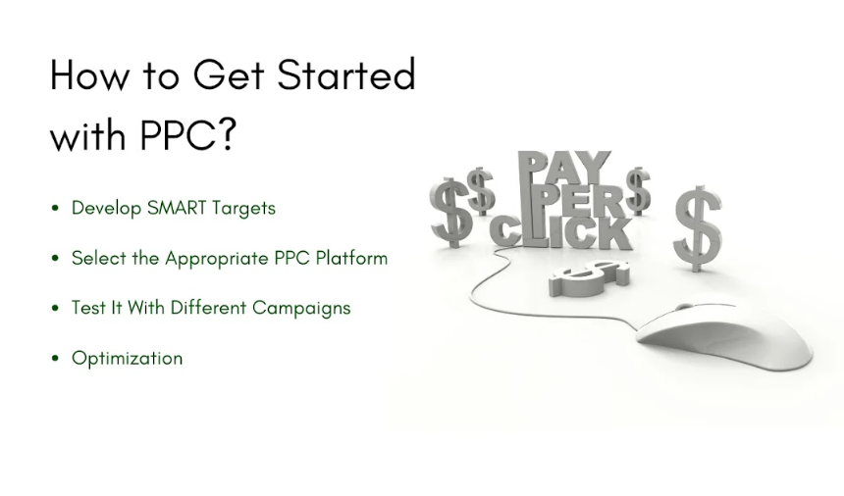

- Develop SMART Targets: The first step involves identifying goals for the PPC campaign. Make sure goals are Specific, Measurable, Achievable, Relevant, and Time-bound and key performance indicators should be established.
- Select the Appropriate PPC Platform and Ad Network: Google AdWords is among the most commonly used platforms while Bing Ads can be utilized effectively if it corresponds to the target audience.
- Test It with Different Campaigns: It is advisable at the initial stages to use only one campaign at a time. Some tips you need to follow include; registration of the account, selection of keywords, formation of advertisements and setting the financial limit that can be spent.
- Optimization: While the first plan will be for the initial set of the campaign, you should use the data gathered to optimize the second plan for a greater scale. After being sure of the strategy, consider an expansion strategy.

Tips for Optimizing and Scaling Campaigns Over Time:
- Keywords Revision: Make revisions based on keyword hits, Performance.
- Improve Adverts: You should try varying the scripts or messages that appear on the advert.
- Increase options: There are possibilities to expand your target audience either through demographic targeting or location targeting.

Conclusion:
PPC advertising in 2025 proves to be a sound strategic framework for reaching and attaining the set marketing objectives. In order to do that, you need to grasp the functionality of Google Ads, the general and specific steps of keyword research and handle the PPC campaign efficiently. So, any successful PPC strategy is based on constant research and improvement.
Whether you want to begin a new PPC advertising campaign for a company or want to enhance your existing one, this guide is going to be a perfect introduction to the constantly growing world of digital advertising.
In case you need any more information related to PPC, feel free to contact Three Angle Marketing which is a leading PPC agency in Dubai.

